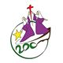
Thabom Bicentenial Celebration

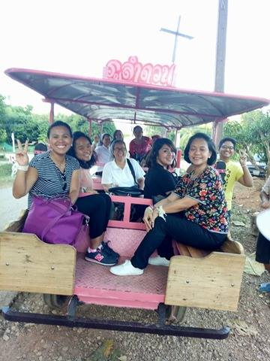
The South East Asia Vocation Promotion Commission joined our sisters in Thabom, Thailand in the closing Celebrations of the Bicentenary birth of our foundresses,
St Marie Eugenie and Mere Therese Emmanuel. Three teachers from San Lorenzo, three teachers from Antipolo, one teacher from Assumpta Technical HS-San Simon Pampanga, Sr. Maria Rosa, and one young professional volunteer form a team of volunteer teachers for the English Youth Camp held in St. John's School-Thabom from Nov 14-17. With them are Sr. Estela Marie and
Sr. Mary Elizabeth of the SEA Voc Pro Commission. It is a beautiful moment of exchange and encounters with the hope that St. Marie Eugenie and the Religious of the Assumption be better known in this side of the world as we try to help in our own little way to bring about God's Kingdom in the hearts of all we encounter.
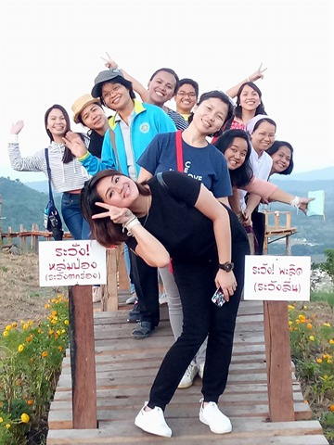
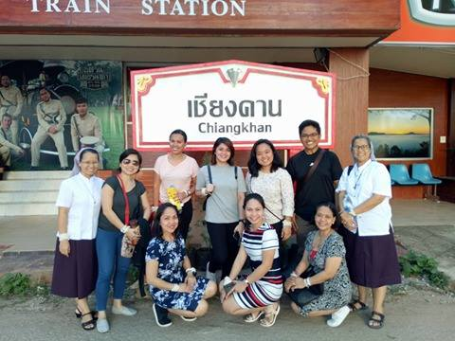
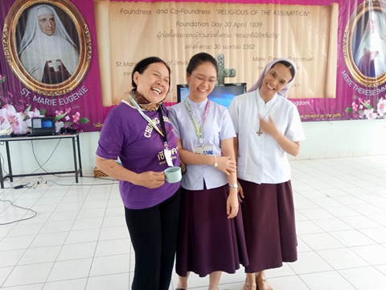

Here are some of their reflections:
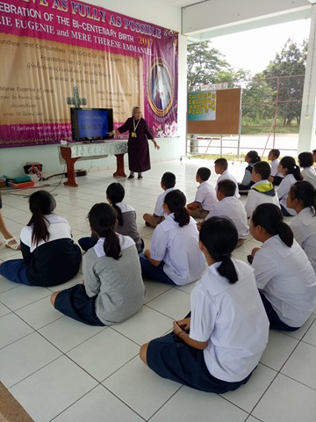
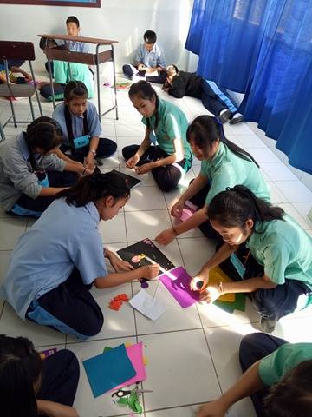
Meaningful and humbling are the two resonating words that can perfectly describe my experience today. The meaningful encounters with students and teachers alike made me more grateful to be in this mission even though it is only a short one. The enthusiasm and willingness of the students to learn pushed me to give my all. Looking at their friendly faces, listening to them enunciate words with much effort, knowing that they were giving their all is such an experience that will be forever etched in my heart. Even the times that I felt frustrated because I was not sure they understood what I was saying did not make the experience less worthy because God sent angels to help me hurdle the challenge. It was also a humbling experience because the moments that I started to doubt myself and my capacity led me to pray. I would utter a prayer and entrusted everything to God. This pulled me back to the thought that I wouldn't go this far with the students if God was not with me. This grounds me that all my talents and skills are all from Him. It made me remember what I learned from our retreat, "I am in God and that is enough." Thank you, Assumption for making me a part of this mission.
(Lime Salisi-Gonzales, Assumption San Lorenzo Teacher)

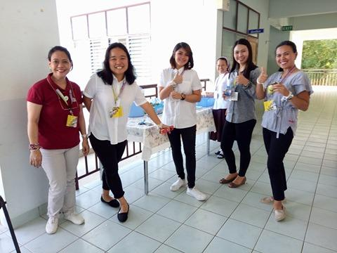
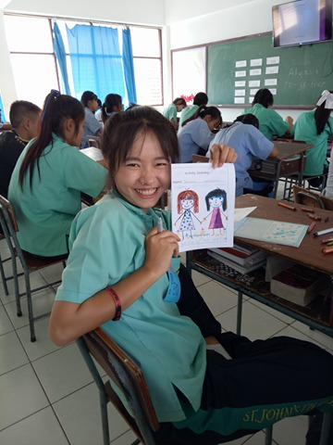

November 16, 2017 (Thursday)
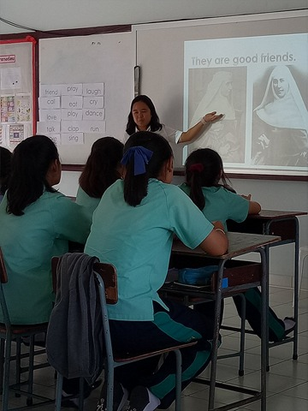
Today was only the second time I ever taught in a classroom (with yesterday being the first). I was still filled with jitters because of my very minimal teaching experience and skill. But with the confidence gained from accomplishing day 1, I was ready for more.
From the entire day 2, it was my encounters while setting for the art exhibits that enlightened me the most. Two Thai students offered to help me set up. Both were girls from the lower grades. As we were taping the posters on the walls, I began asking them simple questions in English. We tackled words from school concepts and activities, to their many interests. Although with some difficulty, they responded very well. We were even sharing simple jokes using simple English. Then, it occurred to me that in spite of my minimal teaching skills and their simple English, we were able to engage in a conversation of learning and fun.
From a rookie teacher’s perspective, the realization struck me as teaching need not be merely a checklist of techniques or a bag full of classroom management tricks. What is needed most is the universal language of love. My love to share myself with others moved me to accept this English Camp mission. The love of the community in the Assumption and in Thabom allowed me to feel at home in this foreign experience. Most especially, having God, who is Love, alongside me and the entire group all throughout the trip fostered a rich learning and fruitful experience.
If invited again to volunteer for such experience, I can willfully and whole-heartedly say yes!
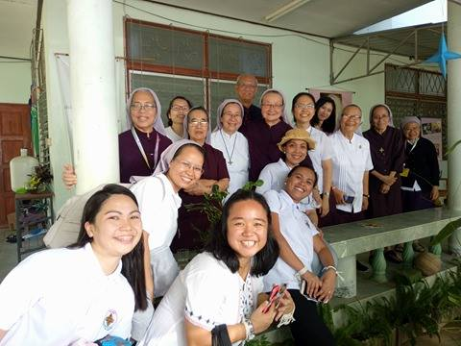
Anne Therese Bautista Martin, Environmentalist
