AT THE END OF THE RAINBOW IS A POT OF... YES!
CHRISTINE EMMANUEL

Rainbow Journey
It has been a long time since a group of six novices professed together for their First Vows - a palpable sign of God's enduring fidelity to the Assumption. Very much like the hidden meaning of the rainbow in the life of humanity, which speaks of God's promise never to destroy the world again. Their journey, if I may borrow from their own word, seemed like that of a rainbow. They have their own colours and uniqueness and gifts which helps each of them propel and reach the pot at the end the rainbow. And on the day of their Vows, the pot of gold has turned into a much precious gem - their Yeses to the One who gave their rainbow colours.

The journey of the six new juniors, Sr. Agnes Cecilia of Jesus Crucified, Sr. Martha Joachim of the Sacred Heart, Sr. Teresa Uyen of the Sacred Hearts of Jesus and Mary, Sr. Fatima Joy of Jesus, Sr. Charmaine Marie of the Most Holy Name of Jesus and Sr. Mary Denyse of the Good Shepherd, was every inch a path prepared by God - the Master craftsman Himself - and we can only delight on it.

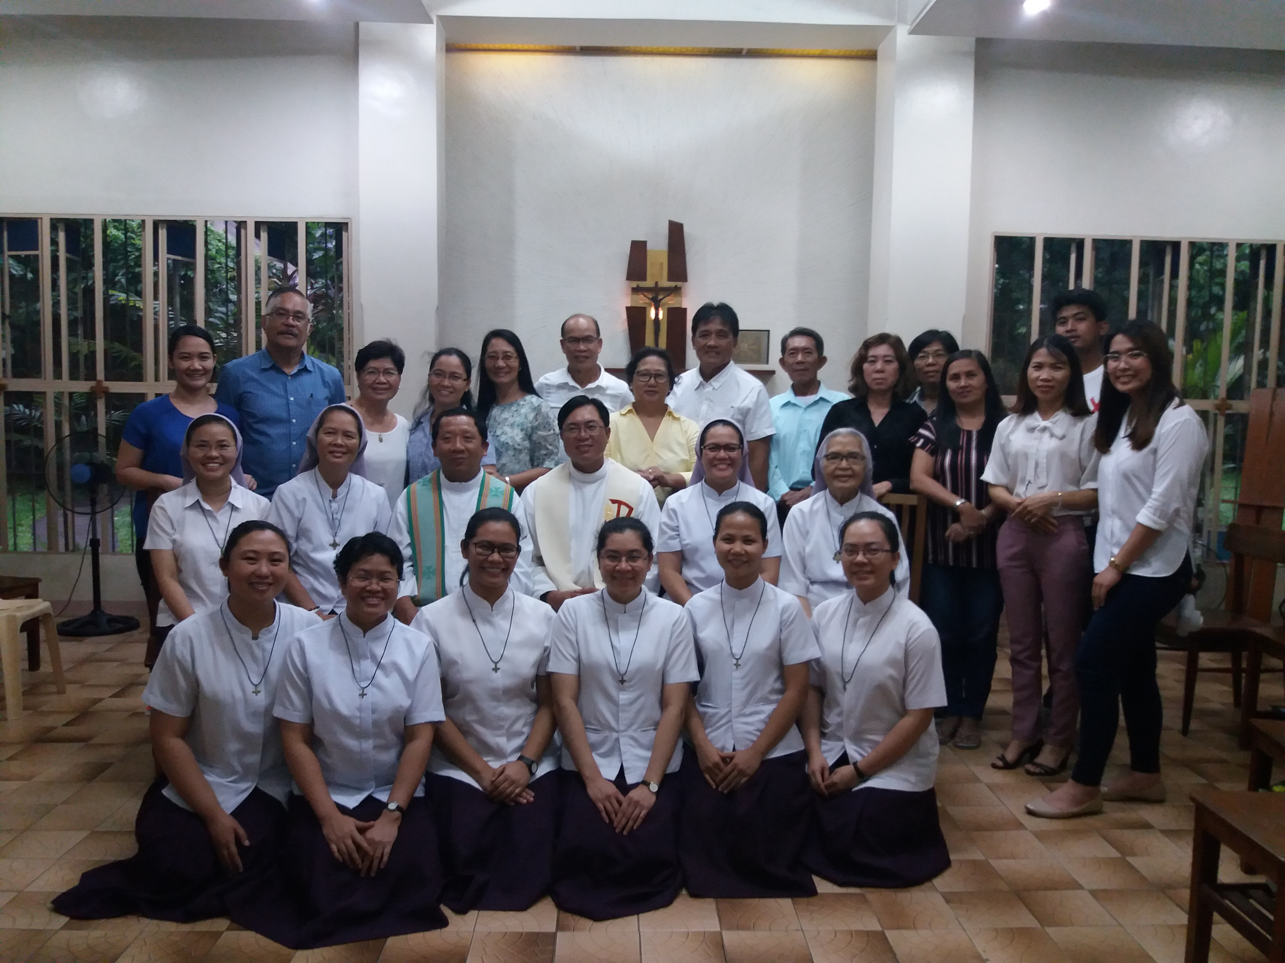Recollection & Entrustment
Before July 3, 2019, the day of their First Profession of Vows, the six had their much awaited reunion with their parents and family. The families of the three Vietnamese Sisters arrived several days ahead while the families of the three Filipina Sisters joined the rest of the group on the day of their recollection on July 2, 2019 at the Novitiate Community. The day was filled with overflowing heart-warming expressions of love and appreciation from the Sisters and their parents, as well as long overdue reconciliations. One parent also shared, "many things have been left unsaid until today." In the end, everyone present in the jam-packed Novitiate library was thankful for what had been, what has been and what will be.

We were also blessed to have the Vietnamese priests with us that day, Fr. Dominic and Fr. Joachim, the parish priest and uncle priest of Sr. Agnes Cecilia and Sr. Martha Joachim, respectively. The community along with the families had a solemn thanksgiving Mass in Vietnamese language. A heart-warming entrustment followed.
Sr. Agnes Cecilia was entrusted by her mother and symbolized her as a bud of a flower. Her mother likes flower and seeing Agnes Cecilia as a little fragrant flower being offered to God. She prayed that as she soon will bloom into a beautiful flower, she may also spread God's fragrance everywhere she will go.
Sr. Martha Joachim's father, entrusted her and offered a little tree - like that of a bonsai - because God gave them a seed and the seed grew like Martha, and now that she's grown up, they offer her to God who can best take care of and love her.
The sister of Sr. Teresa Uyen then followed, she entrusted her with a symbolic smiley painting. Her sister added that religious life is a happy place for Terese Uyen and may she continue to radiate happiness wherever she goes as she offers her life to Jesus.
Sr. Fatima Joy's parents entrusted her with a symbol of a red heart. Her mother said they offer Fatima Joy now and thank her for having such a big heart - for being the bridge between their families and for always taking the extra mile, for always reaching out to almost all of them. She is the glue that keeps them together.
Sr. Charmaine Marie as well was entrusted by her family and they gave a statue of St. Joseph like a doting father to the little Jesus – very much like Charmaine Marie’s close relationship with her father.
Sr. Mary Denyse was the last to be entrusted by her family, they offered a purple comforter and a set of notebooks and pens for her. The family sees Mary Denyse as a source of comfort and joy of the family. Her sisters also acknowledged Mary Denyse’s love for writing and they encouraged her to continue to write beautiful memories of her journey as a religious.

THE VOWS
July 3, 2019 was the most awaited date of the six novices - today, their lives begin anew - one of them said about the feeling of becoming truly an Assumption Sister. Indeed it was an important occasion for all - family and friends alike - all went to the Our Lady of the Assumption Chapel to witness their profession. The Mass began past 10Am with Fr. Paul Quan, OFM as the main presider and Fr. Jerome Rosalinda, the former parish priest of the Nuestra Senora De la Paz y Buen Viaje, was the homilist. In his homily Fr. Jerome encouraged them to have faith like that of St. Thomas, he might be known as the doubting apostle, but he is the personification of a redeemed faith. Thomas, he said, was able to touch the very wounds of Jesus, thus allowing him to fully recover his faith and paved way for the completion of St. John's gospel about Jesus' divinity - the moment of utterance of "My Lord and My God" of St. Thomas. He told the six to always look at Jesus, especially His wounds when trials come and remember that this wounds speaks of love - a love which transcends any trials and struggles.

It was a moment of grace to have witnessed a profession of first vows of a big group. After days of rain prior to the day of the Vows, God, our radiant King of Light, did not withhold the sun that day - as if rejoicing too with us for such a milestone.

In their thanksgiving, Sr. Fatima Joy shared that many would think this era is not the best time to be a religious, but the six say it is the best time, for in their journey, they have witnessed how God never failed to supply colours to their rainbows, to make sure that it shines after each raining moments of their lives. That NOW is the best time to be a religious for God never fails to journey with those who say yes to His invitation.

Indeed, the true colours of the God's unique rainbow was shinning gloriously over Makati skyline on the 3rd day of July - the very feast of a reluctant Apostle who made a lasting remark about Jesus' divinity - "Yes!" "My Lord and my God!"

***

